**WATER QUALITY**

**ANALYSIS**

**BATCH MEMBER**

**712521121023:PREM KUMAR C**

**Phase 5 Submission Document**

**Project Title: Water Quality Analysis**

**Phase5: *Project Documentation and Submission***

**Topic In this section we will document the complete project and prepare it a submission.**

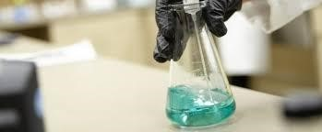

**WATER QUALITY ANALYSIS**

**Introduction:**

Welcome to the Water Quality Analysis Project, where we delve into the intricate world of water quality to safeguard our most vital resource. This initiative aims to comprehensively assess and understand the various parameters influencing water quality, employing cutting-edge analytical techniques. From chemical composition to microbiological aspects, we strive to unravel the complexities, ensuring a sustainable and healthier aquatic environment for generations to come. Join us on this journey as we explore, analyze, and contribute to the conservation of our precious water resources."

**Given Data Set:**

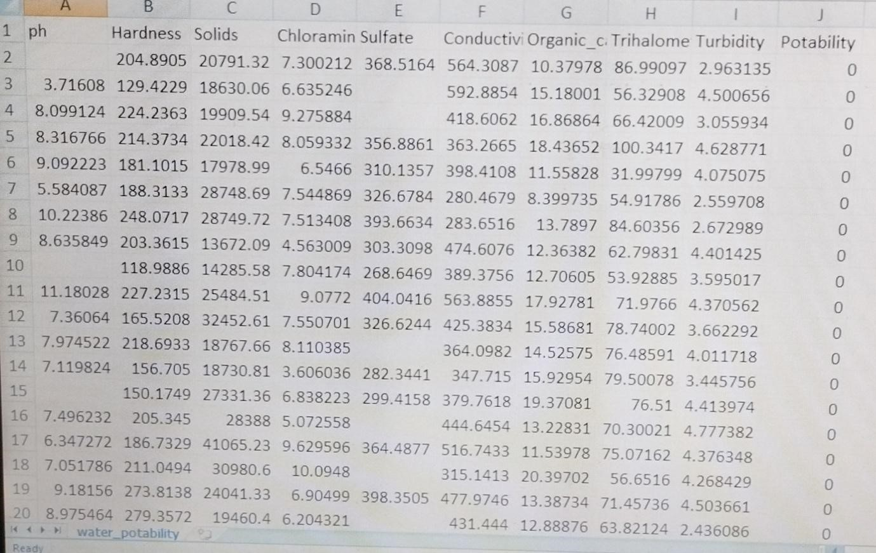

3277 rows*7 columns

**Overview of the process:**

1. Sample Collection:

* + Select sampling sites that represent the area of interest.
  + Use clean containers and equipment to collect water samples.
  + Ensure proper labelling and documentation of sample location and time.

1. Preservation:

* + Some samples may require immediate analysis, while others may need preservation to prevent changes in their properties. Common preservation methods include cooling, acidification, or adding specific chemicals.

3.Pre-processing:

* + Filtration: Remove particulate matter using filters to obtain a clear liquid sample.
  + Homogenization: Mix the sample to ensure a representative composition.

Physical Parameters Analysis:

* + Temperature: Measure water temperature using a thermometer or a sensor.
  + pH: Determine the acidity or alkalinity of the water with a pH meter.
  + Turbidity: Assess water cloudiness or clarity using a turbid meter.

Chemical Parameters Analysis:

* + Dissolved Oxygen (DO): Measure the concentration of oxygen in the water.
  + Conductivity: Assess water's ability to conduct electrical current.
  + Nutrients (e.g., nitrates, phosphates): Analyze the levels of essential nutrients.
  + Heavy Metals: Test for the presence of potentially toxic elements like lead, mercury, and cadmium.
  + Organic Contaminants: Detect organic compounds, such as pesticides or hydrocarbons.

Biological Parameters Analysis:

* + Bacterial Analysis: Assess the presence of coli form bacteria or pathogens.
  + Algal and Phytoplankton Analysis: Identify and quantify microscopic organisms.
  + Macro invertebrates: Study aquatic insects, worms, and other macro invertebrates as indicators of water quality.

Data Interpretation:

* + Compare the results to water quality standards, guidelines, or regulatory limits.
  + Assess the implications for human health, aquatic ecosystems, and intended water uses.

Reporting:

* + Prepare a detailed report summarizing the findings, methods used, and conclusions.
  + Share the results with relevant authorities, stakeholders, or the public.

**Necessary steps to follow:**

1. Import Libraries:

Import sys print(sys.version)

1. Understanding the data:

Firstly, we need to understand the data that we are working with. As the file format is a csv file, the standard pandas import statement using read_csv will be used.

|  |
| --- |
| # Import the dataset for review as a Data Frame  df = pd.read_csv("../input/water-portability/water_portability.csv")    # Review the first five observations df.head() |

|  |  |  |
| --- | --- | --- |
| Having imported the data, the code assigns the variable df with the Data Frame output results from the pandas method. | | |
|  |  |  |

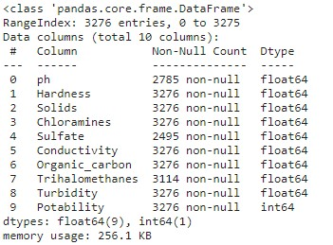 Output: Provides an overview of the features and details of memory usage

# Shape of the DataFrame

-

shows tuple of (#Rows, #Columns)

print

(

df.shape

)

# Find the number of rows within a DataFrame

print

(

len

df

)

)

(

# Extracting information from the shape tuple

print

(

f'Number of rows:

{

df.shape

[

0

]}

\

nNumber of columns:

{

df.shape

[

1

]}

'

When calling an attribute in Python such as shape, there will be no parenthesis required. An attribute is a data result that can be accessed by both a class and its object. Earlier we reviewed a method which is a function that is contained within a class. For further insights on the smaller details a deep dive into how Python class statements function would be required. However, we can continue with the code that is used and show that with output 1.3 a number of values have been displayed.

Output:

No of rows:3276 No of columns:10

**Model training:**

1. **Data Collection**:

Gather a comprehensive dataset of water quality measurements. This dataset should include various parameters such as pH, turbidity, dissolved oxygen, temperature, nutrient levels, and pollutants. Make sure the data is representative of the conditions you want to analyze.

1. **Data Pre-processing**:

Clean the data by handling missing values, outliers, and inconsistencies. Normalize or standardize the data to ensure that all parameters have the same scale, which is crucial for many machine learning algorithms.

Feature Selection: Identify the most relevant features (parameters) for your analysis. Some parameters may have more influence on water quality than others. Feature selection techniques can help you choose the most important variables.

1. **Model Selection**:

Choose an appropriate machine learning or statistical model for your analysis. Common models for water quality analysis include regression models (e.g., linear regression), decision trees, random forests, or deep learning models like neural networks.

1. **Training the Model**:

Split your dataset into a training set and a testing set to train and evaluate your model. Train the model using the training data, and tune hyper parameters to improve performance.

1. **Model Evaluation**:

Use metrics like Mean Absolute Error, Root Mean Squared Error, or others depending on the specific goals of your analysis to evaluate the model's performance. Cross-validation can help assess how well the model generalizes to new data.

1. **Interpretability**:

If your analysis requires understanding the factors influencing water quality, consider using interpretable models or techniques to explain the model's predictions. Explainable AI can be valuable in this context.

1. **Deployment**:

Once you have a trained and validated model, deploy it for real-world applications. This might involve integrating it into a monitoring system, a mobile app, or a web platform to provide real-time or periodic water quality predictions or alerts.

1. **Continuous Improvement**:

Regularly update and retrain the model as new data becomes available to ensure that it remains accurate and relevant.

Compliance and Regulations: Ensure that your model and its predictions comply with local and national water quality regulations and standards.

Remember that the success of your model depends on the quality of your data, the choice of the appropriate features, and the selection of a suitable machine learning algorithm. It's also essential to involve domain experts who understand water quality to guide the process and interpret the results effectively.

Challenge involved in loading and pre-processing of water quality analysis

1.Data Sources: Water quality data can come from multiple sources, such as sensors, lab tests, or manual measurements, each with its own format and quality issues. Combining and standardizing these sources can be complex.

1. Missing Data: Incomplete or missing data points are common in water quality datasets. Deciding how to handle missing values, like imputation or removal, can impact the quality of analysis.
2. Data Volume: Large datasets with high temporal and spatial resolution can be challenging to manage and process efficiently, requiring specialized tools and hardware.
3. Temporal and Spatial Variability: Water quality can vary over time and across locations, necessitating techniques to aggregate or interpolate data for meaningful analysis.
4. Data Transformation: Depending on the analysis goals, data may need various transformations, such as normalization, filtering, or feature engineering.
5. Data Exploration: Understanding the dataset's characteristics and patterns is crucial but can be time-consuming, especially with large datasets.
6. Tools and Software: Using appropriate software and tools for data manipulation, analysis, and visualization is important, and it may require a learning curve.
7. Automation and Scalability: For ongoing monitoring, setting up automated pipelines and scalable solutions is essential to handle continuous data streams.

Output Dataset:

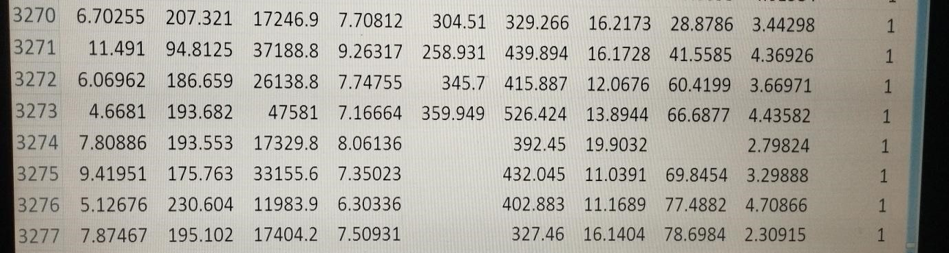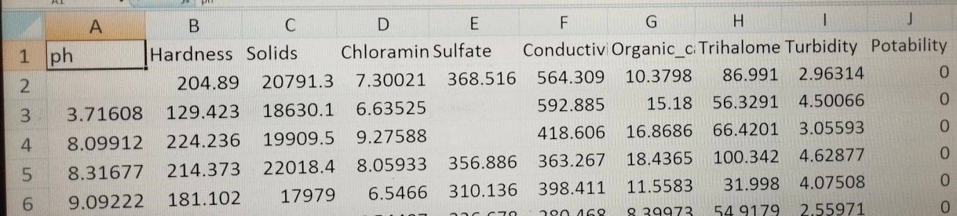

**Visualisation and pre-processing of data:**

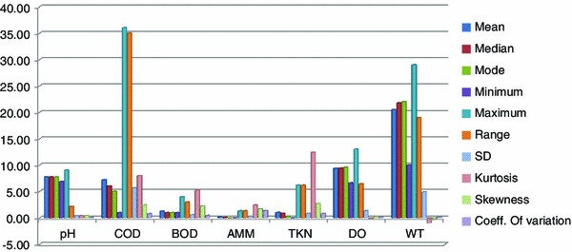

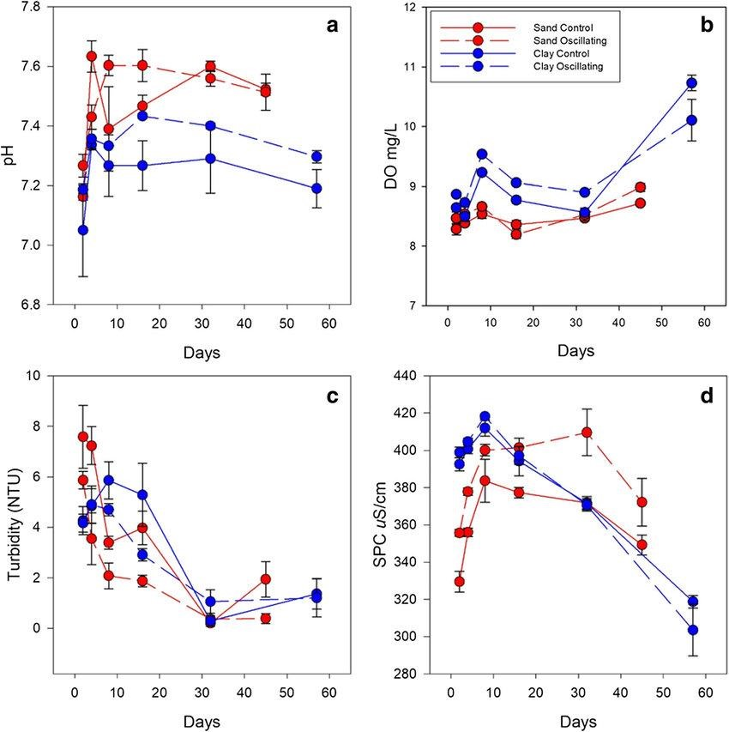

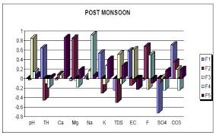

**Feature Engineering:**

Feature engineering is a crucial aspect of water quality analysis, enabling the extraction of valuable insights from raw data. This process involves the creation of relevant features to better understand and model water quality parameters. Various techniques can be employed, including temporal features like hourly or seasonal averages, statistical measures to capture data distribution, and the calculation of lag variables or moving averages to identify trends and autocorrelations. Interaction features that explore relationships between different parameters, categorical encoding for location data and the incorporation of domain-specific information such as weather or land use can all enhance the analysis. Seasonal decomposition, frequency analysis, and time series features.

Advantages:

Drinking water testing can identify the presence of harmful contaminants, such as bacteria, viruses, and chemicals, ensuring that the water is safe to drink. Regular drinking water testing can help ensure that water supplies meet relevant health and safety standards, protecting consumers from potential harm.

Disadvantages:

There will need to be testing at multiple locations if the area to be studied is large. Continual assessments of the water's quality will be difficult and timeconsuming. Consequently, a real-time monitoring system is needed to safeguard the water and keep track of its condition in order to stop contamination.

Conclusion:

"In conclusion, our Water Quality Analysis Project has provided valuable insights into the health and sustainability of our water systems. Through meticulous testing and examination of diverse parameters, we've uncovered crucial information about chemical, physical, and microbiological aspects. This knowledge forms the foundation for informed decision-making to enhance water quality management. As we navigate the challenges posed by pollution and environmental changes, the significance of ongoing monitoring and proactive measures becomes evident. Together, let's strive for a future where clean water is a guarantee, not just for us but for the delicate ecosystems that depend on it."